PATH to LICENSURE In the State of Minnesota



Architect Licensing Advisory Committee

International Market Square

612-388-6763

[Christiansen@aia-mn.org](mailto:Christiansen@aia-mn.org)

August 2017

This document outlines and clarifies the steps necessary to move from being an associate to an architect in the State of Minnesota. With all the information that exists on the web coupled with potentially conflicting advice from those who’ve taken the exams it is often difficult to find your own path. Because everyone’s experience is different there is no black and white path to follow, but the intent of this document is to give the most comprehensive list of steps a licensure candidate will need to take to reach licensure in the State of Minnesota.

Table of Contents

PATH TO LICENSURE: OVERVIEW 3

STEP BY STEP…………… 4

**EDUCATION** | NAAB 4

**EXPERIENCE** | AXP 5

What is Architectural Expereince Program (AXP)? 5

How is AXP broken down? 5

**EXAMINATION** | ARE 7

STEP 1. Open Your Record With The State 7

STEP 2. Have NCARB Send Proof of Your Record 8

STEP 3. Strategize Your Exam Schedule 9

STEP 4. Begin and Continue to Study 9

STEP 5. Receive Authorization to Test from State 9

STEP 6. Schedule Your Exams 9

ARE TIMELINE: 10

MINNESOTA LICENSE: 11

Overview of Recent Changes to the AXP/ARE Process 12

REFERENCES and DEFINITIONS 13

This document is purely a reference guide and is based off information gathered from many sources. It contains recommendations but is in no way intended to replace due diligence by each candidate. It is the responsibility of each candidate to make sure they are up to date with the latest and most relevant information available. Please see the References and Definitions portion of this document for links to other resources.

# PATH TO LICENSURE: OVERVIEW

the three ‘e’s of licensure: education, experience, examination

Completion of all (3) is required to obtain licensure in Minnesota. See below for specific guidance in each of the categories.

# STEP BY STEP……………

## http://kuresel-yurtdisiegitim.com/sys_upload/images/Education%201.jpgEDUCATION | NAAB

Minnesota State Board requires a Professional Degree from an NAAB accredited program

Current NAAB Accredited Institutions in Minnesota:

University of Minnesota-School of Architecture: Master of Architecture

<http://arch.design.umn.edu/programs/m_arch/>

NAAB Accreditation in progress (anticipated accreditation Spring 2018):

Dunwoody College of Technology: Bachelor of Architecture

<http://www.dunwoody.edu/construction/architecture/>

Complete NAAB Accredited program and send Official Transcripts to NCARB using their transcript request form:

<http://www.ncarb.org/en/FAQs/Education/Verify-Education.aspx>

(NOTE: sending a hard copy of transcript request form aids in a smoother validation of your education with NCARB).

## EXPERIENCE | AXP

### What is Architectural Experience Program [AXP]?

“In most jurisdictions, completion of the AXP is a requirement for initial registration. The AXP identifies the comprehensive experience that is essential for competent practice.

The program is structured to prepare you to practice architecture independently upon initial registration.”

<http://www.ncarb.org/axp>

NCARB is responsible for administering AXP policy.

### How is AXP broken down?

**3,740 Core Minimum Hours**

* The AXP identifies 96 key tasks that are in six practice areas.
* Candidates must demonstrate the ability to perform specific tasks, reporting a total of 3,740 hours across the six areas.

**Practice Management** (160 Minimum Hours)

**Project Management** (360 Min. Hours)

**Programming & Analysis** (260 Min. Hours)

**Project Planning & Design** (1080 Min. Hours)

**Project Development & Documentation** (1520 Min. Hours)

**Construction & Evaluation** (360 Min. Hours)

*Note: NCARB Model law eliminated Elective Hours from IDP Requirements June, 2015. The State of Minnesota adopted these changes.

**AXP Getting Started:**

Step 1: Establish an NCARB Record

<https://www.ncarb.org/gain-axp-experience/start-axp/establishing-your-ncarb-record>

Step 2: Document your AXP Eligibility Date

Step 3: Identify your AXP Supervisor

Step 4: Identify your Mentor (Optional but recommended to enhance your AXP experience)

Step 5: Document Your Experience

Repeat Step 5 Often…every 6 months at least

**6 Month Rule**:

* Candidates shall report their hours online to NCARB for reporting periods of no longer than six months duration in each report.
* Each report form must be entered online no later than two months after the end of the period being reported. Only experience hours submitted within such two-month filing period will be accepted.

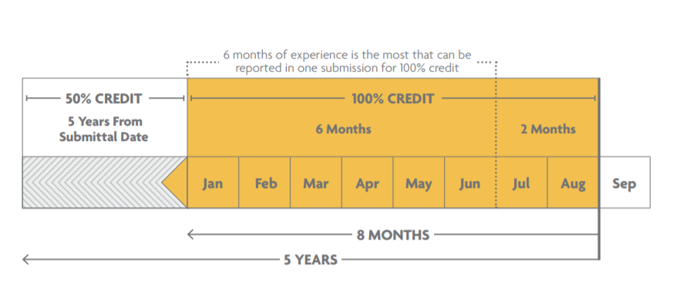

**Once AXP is completed** you will be able to see ‘100% complete’ status on your MyNCARB page <https://my.ncarb.org/>.

No additional confirmation will be sent. No additional submission to the state board or NCARB is necessary.

## EXAMINATION | ARE

The most common confusion with Licensure is experienced precisely at the point one decides they want to begin taking sections of the Exam. What do you need to do when you think you’re ready to sit for the Exam? When can you submit to your state and who reviews what?

This section is an attempt to organize concisely the steps that you need to take in the state of Minnesota to successfully complete the Experience and Examination portions of the Intern Development Process.

1. 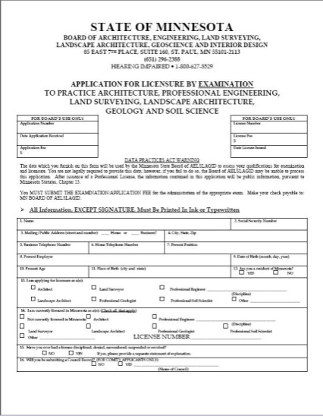Open Your Record With The State. You will need to complete the application accompanied by a $75.00 fee. Figure 1 shows an example of the front page of the application you can find at the following website: [**http://mn.gov/aelslag/ARExamApp.pdf**](http://mn.gov/aelslag/ARExamApp.pdf)

Excerpt:

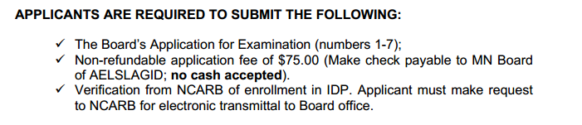

See Step 2

* 1. IMPORTANT NOTE: Records with the state remain active for 3 years without any additional effort. If they have not been active for 3 years then they will be de-activated and potentially problematic to get re-activated. If that inactivity extends to a total of 5 years then the file is physically shredded and GONE FOREVER.

Figure : Excerpt from State of Minnesota: Application for Examination

1. Have NCARB Send Proof of Your Record. Go to the My NCARB Record page on NCARB’s website and Request Transmittal of Record. Make sure you have paid all applicable fees to NCARB. Select Minnesota as your jurisdiction, and if you have not completed the IDP Hours, be sure to check the box next to ARE Early Eligibility. This step is your request of the State to grant you Authorization to Test.

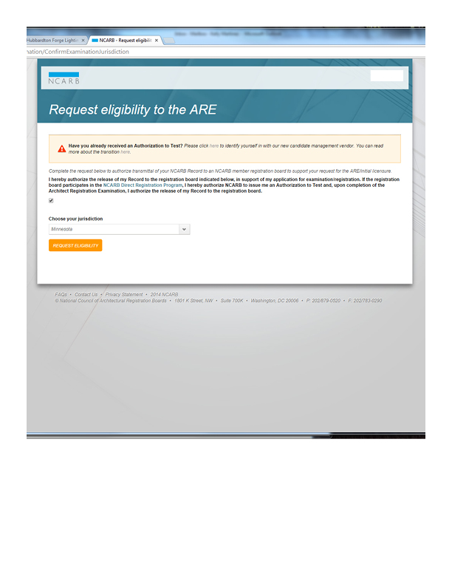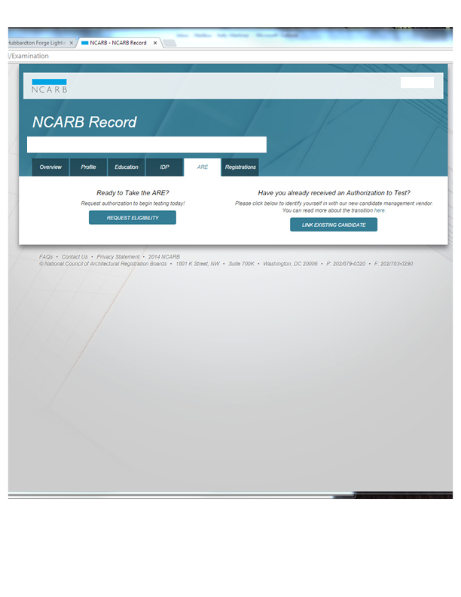 🡪

Figure 2: Screen shots from My NCARB

* 1. If applying for Early Eligibility to sit for the exams, the State Board will check with your NCARB Record to ensure your Education has been documented (i.e. Your official transcript needs to be on file with NCARB [see EDUCATION section of this Document]. Your transcript does not need to be sent to the State Board directly).Meanwhile…

1. Strategize Your Exam Schedule. Prepare a timeline/plan for your exam schedule and completion of IDP Hours.
2. Begin and Continue to Study for your exams
3. AXP Committee Resources <http://www.aia-mn.org/events/continuing-education/axp/>
4. ARE Review Materials and Related Links: <http://www.aia-mn.org/events/continuing-education/are/>
5. AIA Resources <http://www.aia.org/career-center>
6. ARE 5.0 Community <https://are5community.ncarb.org>
7. Receive Authorization to Test from State. The State will notify you that you are authorized to test (allow approx. 6-8 weeks from submittal)
8. 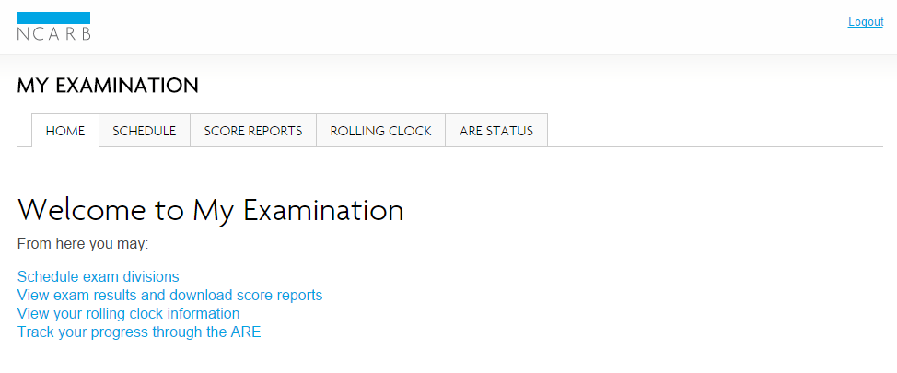Schedule Your Exams. Prometric is the testing center that administers the AREs but you can schedule exams, modify scheduled exams, and view score reports on the “ARE” tab 🡪 “My Examination” on “My NCARB”.

Figure 3: Screen shot from My NCARB

1. After successful completion of the AREs and AXP, Formally Request that NCARB Transmit your Record to the state licensing board by going to NCARB’s website and reviewing your NCARB Record.

Best of luck to each of you! If you need any assistance please feel free to contact the Architect Licensing Advisory Committee. Any one of us would be happy to help. <http://www.aia-mn.org/get-involved/committees/alac/>

### ARE TIMELINE:

# MINNESOTA LICENSE:

After successful Completion of EDUCATION, EXPERIENCE, EXAMINATION:

# Overview of Recent Changes to the AXP/ARE Process

ARE

IDP/AXP

# REFERENCES and DEFINITIONS

AIA CAREER STAGES: GET LICENSED - <https://www.aia.org/pages/2651-getting-licensed>

MINNESOTA LICENSING BOARD- <http://mn.gov/aelslagid/>

NCARB <http://www.ncarb.org/>

ARE GUIDELINES <https://www.ncarb.org/sites/default/files/ARE5-Guidelines.pdf>

ARE HANDBOOK <https://www.ncarb.org/sites/default/files/ARE5-Handbook.pdf>

AXP GUIDELINES <https://www.ncarb.org/sites/default/files/AXP-Guidelines.pdf>